IoT Home Security Network Configuration Using Cisco Packet Tracer

Student: Daniel Olalekan Kolawole
Lab: IoT Home Security Network
Platform: Cisco Packet Tracer
Category: Networking / IoT Security

Introduction
This practical lab was carried out using Cisco Packet Tracer to demonstrate how IoT devices can be connected to a wireless network, registered with a remote IoT registration server, and configured to improve the physical security of a home.
The lab involved connecting IoT security devices such as a siren and door, configuring their network connectivity, registering the IoT devices with a registration server, and exploring the security functionality available within the IoT environment.
The purpose of this exercise was to gain practical experience with IoT networking, device connectivity, registration servers, and basic IoT security concepts.

Objectives
The objectives of this lab were to:
Connect IoT devices to a wireless network.
Connect and configure the IoT siren and home door.
Add IoT devices to an IoT registration server.
Establish communication between the IoT devices and the registration server.
Explore the security functionality of IoT security devices.
Understand how IoT devices can be used to improve physical security

Background / Scenario
In this scenario, the objective was to increase the physical security of a home while the homeowner was away.
IoT devices were installed and connected to a wireless network so that they could communicate with a remote IoT registration server. This setup allows the security devices to be monitored and controlled through the network.
The practical exercise demonstrates how networking and IoT technologies can be integrated into a home security system

Tools and Technologies Used
Cisco Packet Tracer
IoT Devices
Wireless Network
IoT Registration Server
Home Gateway/Wireless Network
Home Door
Home Siren
IoT Custom Cable

Lab Procedure
Part 1: Connect IoT Devices to the Network
Step 1: Connect the Siren to the Door
The first step was to connect the Home_Siren to the Home Doors device.
Procedure:
I navigated to the Home environment in Cisco Packet Tracer.
I located the Home_Siren and Home Doors devices in the living room.
From the bottom toolbar, I selected Connections.
I selected the IoT Custom Cable.
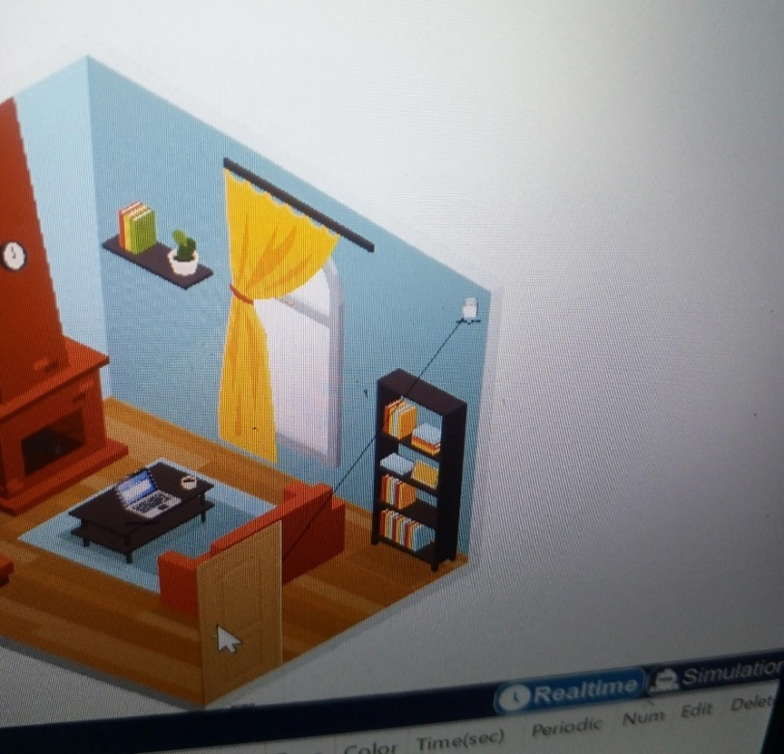
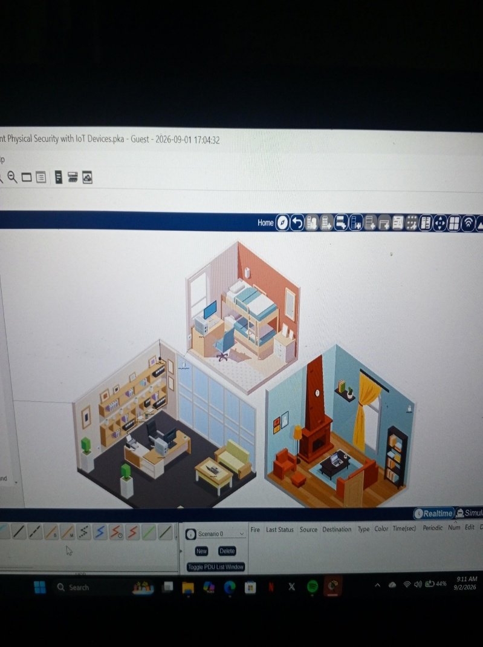
I connected the Home_Siren DO interface to the Home Doors DO interface.

After establishing the connection, I tested the door to verify that the siren responded appropriately.

Held the ALT key and clicked the door to test the connection/functionality.

Step 2: I Associate all IoT Devices to HomeNet Wireless Network
Procedure
- I first located the Home siren, Home Doors, Home Motion and Home webcam

- I then clicked Home siren and then Config tab > Wireless0

- I configure the SSID and the Authentication Mode

I set the SSID to HomeNet
Authentication To WPA2-PSK
I set the Pass Phrase To Ciscorocks
- I then clicked on IP configuration , clicked DHCP
I verify if the device received an IP address from the 192.168.0.024 Network
- I recorded the MAC address for the IoT device
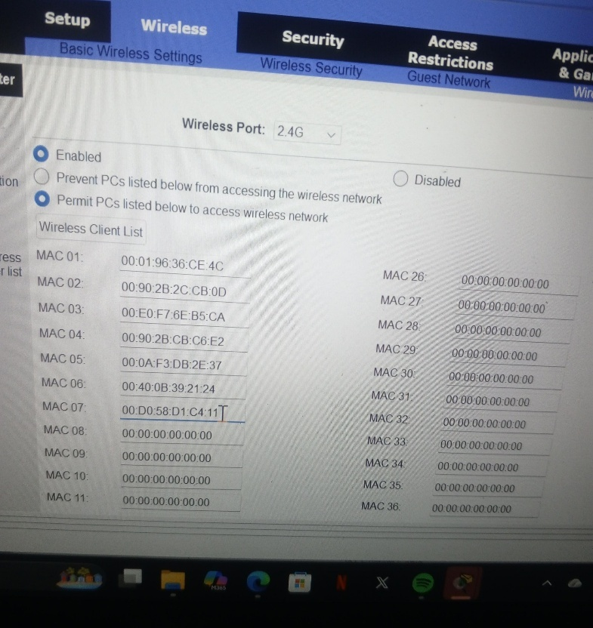
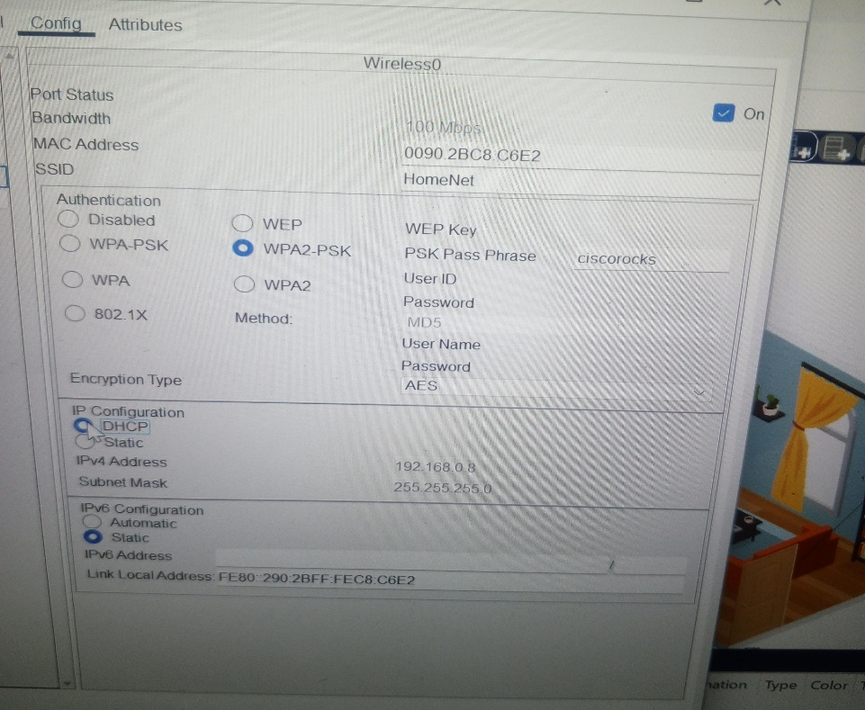
Format the address with Colon between each two(2) Hexadecimal numbers instead of a period between each four hexadecimal numbers
I repeat same congratulations steps for each of the IoT devices

Procedure 3: Congratulations of MAC address Filtering to allow the IoT Devices

Step 1. I clicked Home Office PC > Desktop tab> Web Browser
Step2. I login to the Home Wireless Router at 192.168.0.1, I used admin as the username and password
Step 3. I Clicked Home Wireless Router> GUI tab
Step 4. I clicked Wireless and then Wireless MAC filter
Step 5. I verify that the filter the Filter is enabled for the 2.4 GHZ Wireless port and that is set to permit PCs to access Wireless network
Step6. I added the four(4) IoT Devices MAC addresses to the Table and then clicked save
Step7. I then Close the Web Browser and click IP Configuration to renew the IP address configuration, The Home office PC then received an IP address from the 192.168.0.0/24 Network

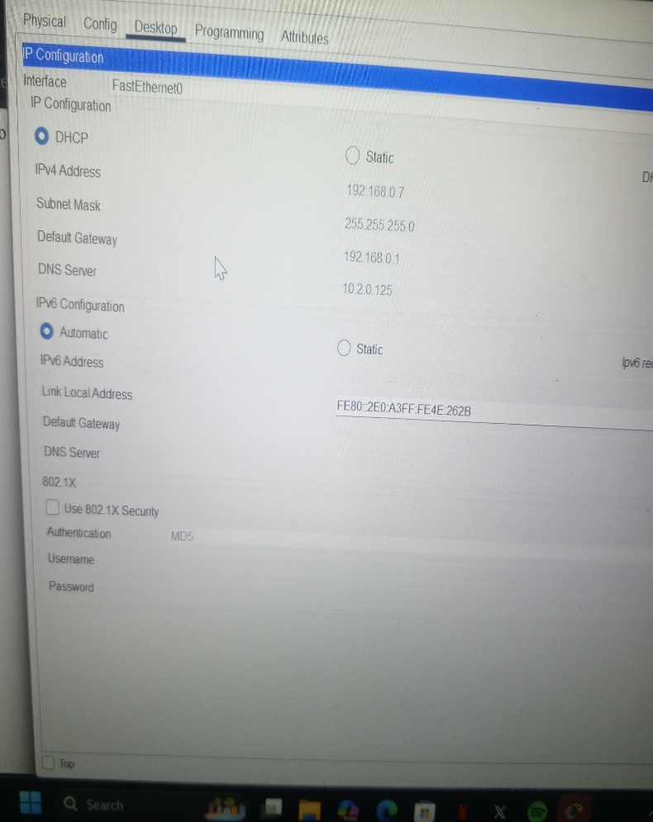

Procedure 3. I Added IoT Devices to the registration server

Step 1. I created an account on the ISP ioT registration server
On the Home office PC, I close IP configuration and then clicked Web browser,bi navigate to https://10.3.0.125
I then clicked sign up and created a new account with the username HomeUser and password: Pa$$w0rd
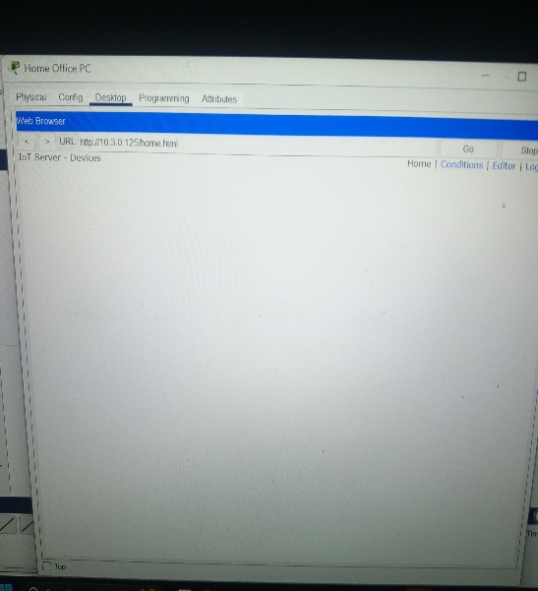
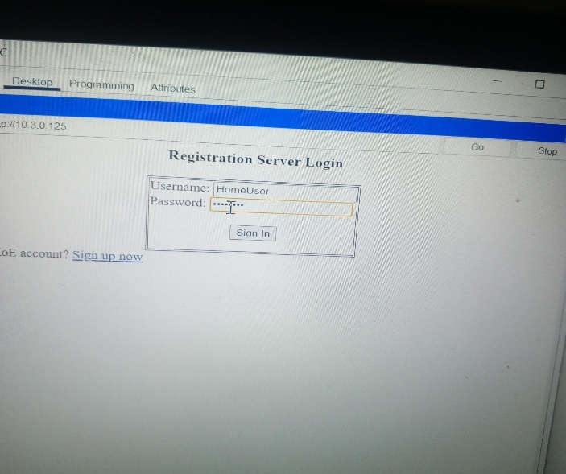

Procedure 4: I Register each IoT Devices with the Registration server
I register each of the IoT devices with the registration server to remotely monitor and manage the device

Step 1. I clicked the device> Config tab> settings under GLOBAL
Step2. I scroll to the IoT section at the bottom of the Page and enter the following information
Remote server
Server Address: 10.3.0.125
User Name HomeUser
Password: Pa$$w0rd and then clicked connect the connecting will change to refresh
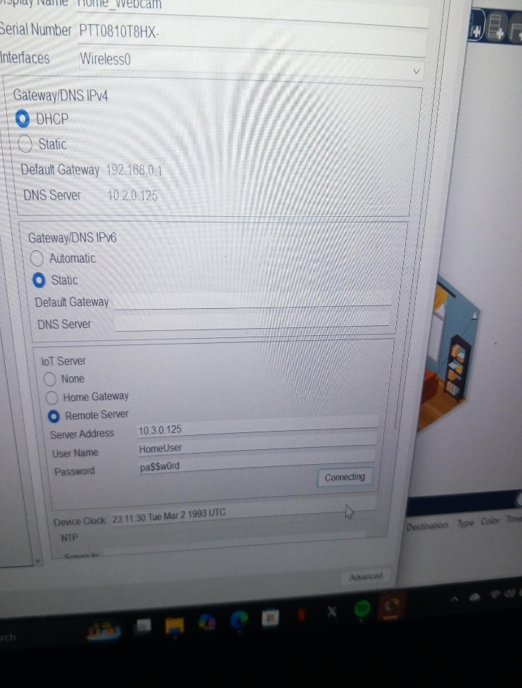
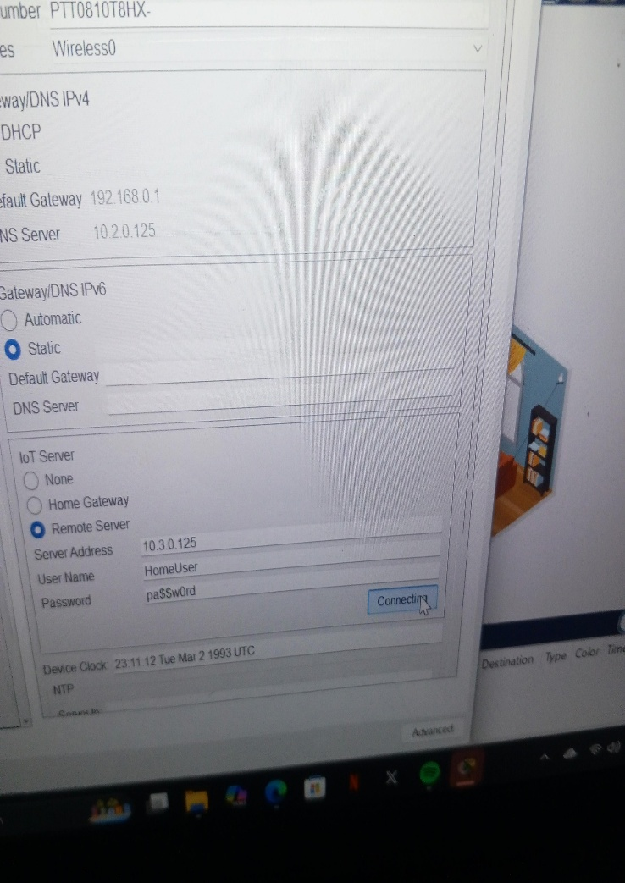
I repeat the same steps to register all the IoT Devices

Procedure 4: I verify all devices are registered
Step1. I returned to the Web browser on the Home office PC and then browse 10.3.0.125
And login with the username:HomeUser and password: Pa$$w0rd
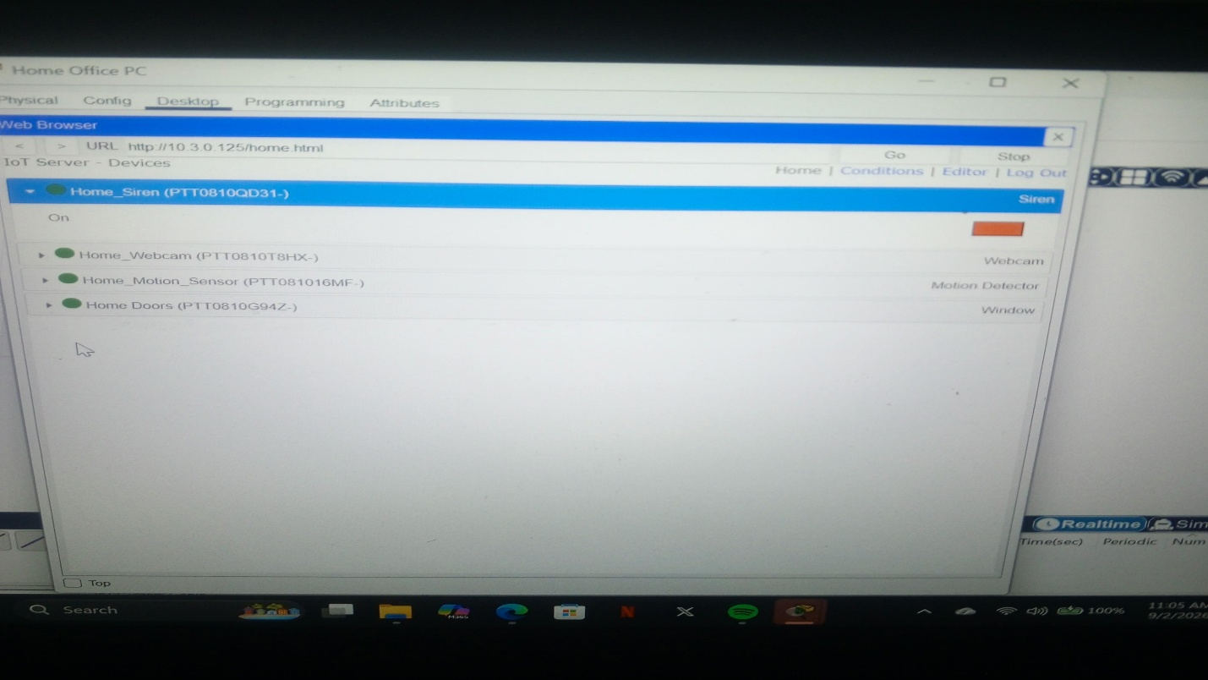
Step 2: I verify all the four (4) IoT devices are registered on the server
I clicked each section of the IoT devices to display the device details
I clicked on the red rectangle under the Home Doors to activate it which it will show red
I clicked it again to deactivate it which it shows green
I clicked the green rectangle for the Home webcam which off the Webcam
I clicked it again to on it
I clicked the red circle for Home sensor, meanwhile nothing changed because the motion sensor only send information to the registration server

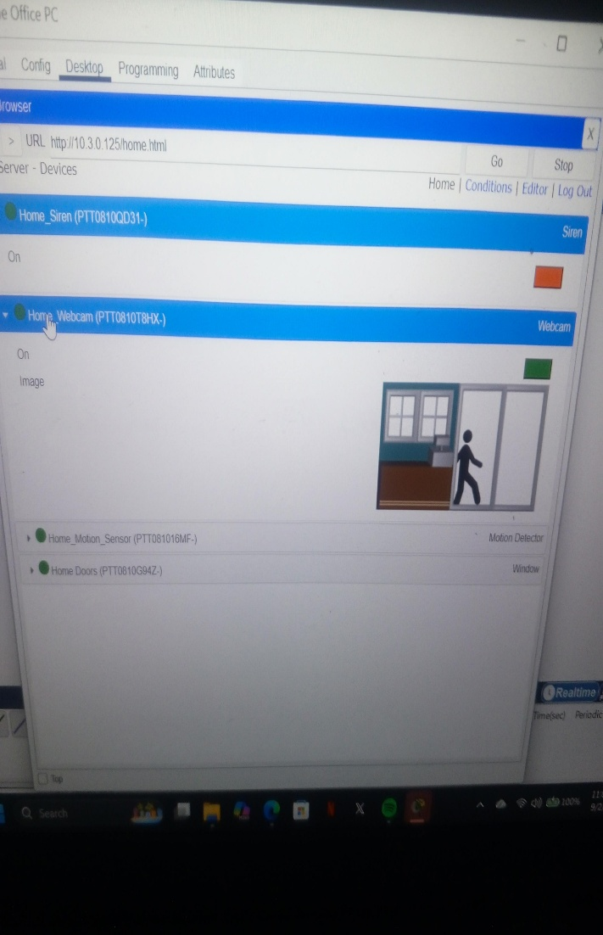
Note: In packet tracer,The IoT Devices can Normally be activated by holding down the ALT
key and then Clicking the device, while the motion sensor is activated by Holding the ALT key and Moving the Mouse over the sensor

